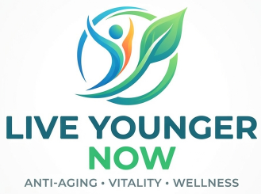
Thank You For Connecting!
It was a pleasure meeting you and discussing the future of wellness, longevity, and entrepreneurial freedom. This document outlines the exact NuXtrax business opportunity we spoke about, so you have all the core details in one place.

The Market Opportunity
The global demand for anti-aging, cellular health, and natural energy solutions is growing exponentially. Through NuXtrax, independent entrepreneurs can capitalize on this shifting market by introducing clean, plant-based longevity technology to health-conscious consumers.

🧪 Our Breakthrough Product Line
We focus entirely on superior daily supportive nutrition using premium, contaminant-free plant extracts. The primary product ecosystem includes:
- iHeRQles: Our flagship microcirculation spray designed to support cellular health, longevity, and telomeres.
- iRevive: A premium topical wellness cream formulated for rapid skin restoration.
- iPatches: Frequency-aligned, wearable patches targeting natural energetic balance and stamina.

💰 Two Ways to Earn Income
As a Transformation Affiliate, your business model relies on a dual-income stream approach:
- Direct Sales Commissions: Earn direct retail profits by helping customers access clean, daily cellular support nutrition.
- Network Bonuses: Build, mentor, and earn commission overrides from your own downline team of independent affiliates.

🚀 Your Next Steps
If you are ready to build a flexible revenue stream or enhance your existing wellness brand, here is how to get started today:
- Step 1: Review the quick 3-minute product overview videos directly on my digital business card.
- Step 2: Tap the "Become an Affiliate" button on my digital profile to set up your account.
- Step 3: Schedule our 15-minute onboarding strategy call using my calendar link below.

📞 Contact & Connection Details
- Name: [Client's Name]
- Title: Transformation Affiliate / NuXtrax Team Leader
- Phone: [Client's Phone Number]
- Email: [Client's Email]
- Direct Enrollment Link: [Insert Client's Affiliate Link]

📌 How to Format the Word Doc for NetLynxs:
- Keep it to 1 Page: Busy prospects will not read a multi-page document. Keep spacing tight and clean.
- Add Live Hyperlinks: Highlight text (like "Become an Affiliate" or "calendar link"), right-click, select Link, and paste your client's direct URLs so the document is completely interactive.
- Save as a PDF: While NetLynxs allows file uploads, saving your Word doc as a PDF before uploading ensures the formatting looks identical on both iPhone and Androi

